**DAILY ONLINE ACTIVITIES SUMMARY**

|  |  |  |  |  |  |  |  |  |
| --- | --- | --- | --- | --- | --- | --- | --- | --- |
| **Date:** | **26-05-2020** | | | | | **Name:** | **Nihal Rafiq** | |
| **Sem & Sec** | **4th A** | | | | | **USN:** | **4AL18CS052** | |
| **Online Test Summary** | | | | | | | | |
| **Subject** | | **Design and Analysis of Algorithm** | | | | | | |
| **Max. Marks** | | **30** | | **Score** | | | **25** | |
| **Certification Course Summary** | | | | | | | | |
| **Course** | **Introducer Coding for Beginners: an HTML and CSS Online Course** | | | | | | | |
| **Certificate Provider** | | | **BitDegree** | | **Duration** | | | **60 hrs** |
| **Coding Challenges** | | | | | | | | |
| **Problem Statement:**  **1: Write a program in C to print all permutations of a given strings using pointer.**  **2: Given an array A of size N where the array elements contains value from 1 to N with the duplicates, the task is to find total number of sub arrays which start and end at the same element.** | | | | | | | | |
| **Status: Executed** | | | | | | | | |
| **Uploaded the report in Github** | | | | | **Yes** | | | |
| **If yes Repository name** | | | | | **https://github.com/nihal-art/lockdown-coding** | | | |
| **Uploaded the report in slack** | | | | | **Yes** | | | |

Online Test Details:

The online test was from module 2 of DESIGN AND ANALYSIS OF ALGORITHM (18CS42).Duration of test is 45 minutes from 9.15am to 10.00am .30 questions of multiple choice.

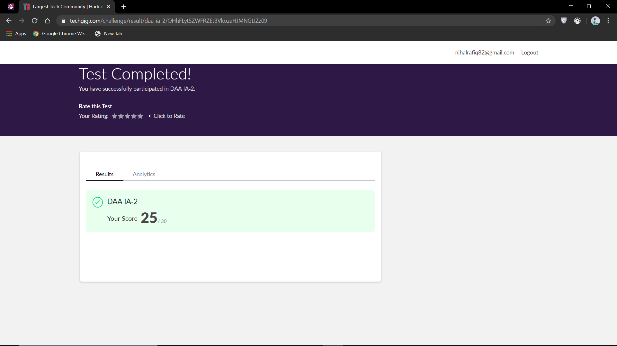

Certification Course Details:

I have opted my Online Certification Course in BitDegree. The course I have opted is Introducing Coding for Beginners: an HTML and CSS Online Course.

The course covers the following topics:

* Basic web development
* Creating forms, buttons and other elements
* HTML coding basics
* CSS basics

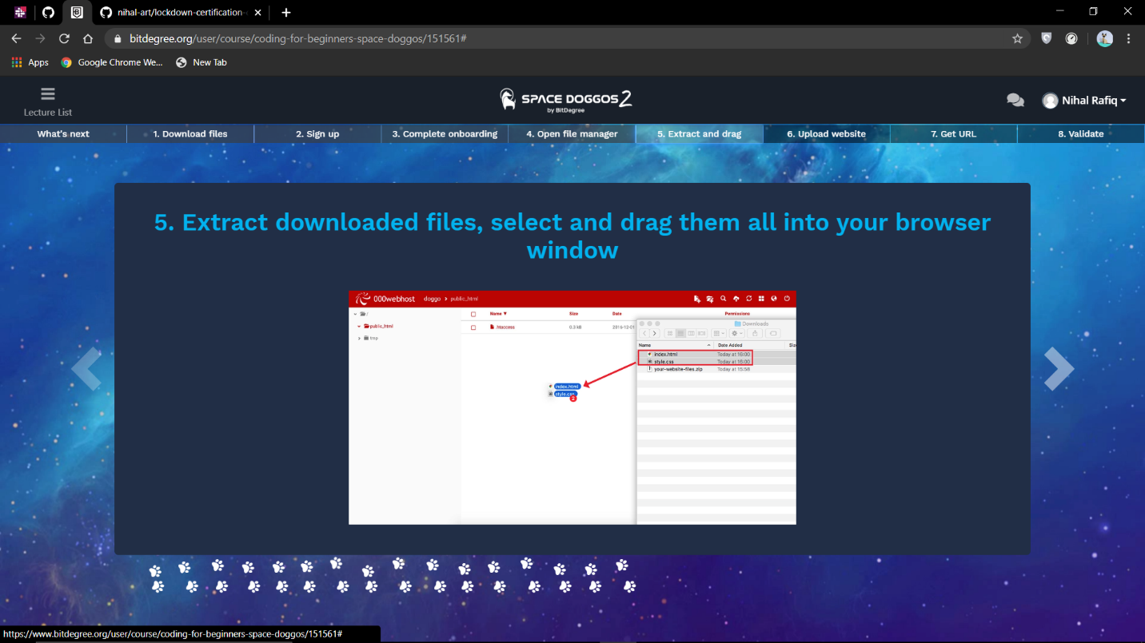

Coding Challenges Details:

1: Write a program in C to print all permutations of a given strings using pointer**.**

Input: Enter the Input String: abcd

The permutations of the string are: abcd abdc acbd acdb adcb adbc bacd badc bcad bcda bdca bdac cbad cbda cabd cadb cdab cdba dbca dbac dcba dcab dacb dabc

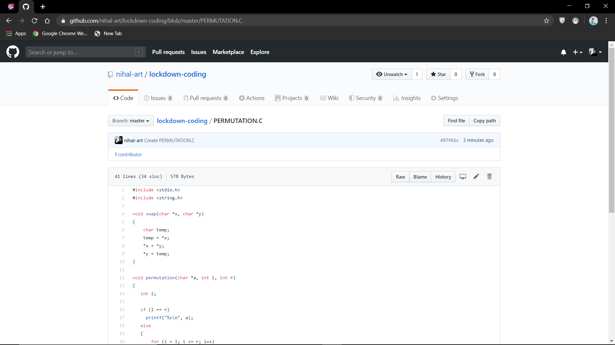

2: Given an array A of size N where the array elements contains value from 1 to N with the duplicates, the task is to find total number of sub arrays which start and end at the same element.

Examples: Input: A [] = {1, 2, 1, 5, 2} Output: 7

Explanation: Total 7 sub-array of the given array are {1}, {2}, {1}, {5}, {2}, {1, 2, 1} and {2, 1, 5, 2} are start and end with same element

